1. PSM, Peptide & Protein Visualization

The search conducted in the Peptide to Spectrum Matching chapter generated two files containing the peptides matched by OMSSA and X!Tandem for each spectrum, so-called Peptide to Spectrum Matches (PSMs). From these we need to find the identified peptides and proteins. This is the task of PeptideShaker ([http://peptide-shaker.googlecode.com](http://peptide-shaker.googlecode.com/)). PeptideShaker is freely available and is still under development so any comments or suggestions will be greatly appreciated!

First, start PeptideShaker by double-clicking the file called PeptideShaker-X.Y.Z.jar in the PeptideShaker-X.Y.Z folder located in the software folder (X.Y.Z is the version number). You should see the following dialog:

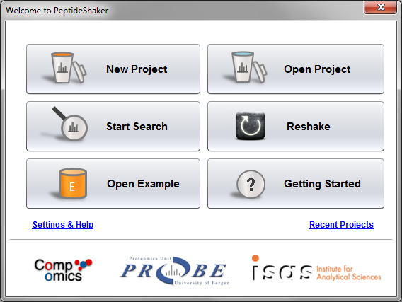

From the Welcome dialog, you can create a new project, open a previously saved project, start a search with SearchGUI, Reshake (i.e., reanalyze) existing PRIDE1 data, open an example dataset or navigate our ‘Getting Started' presentation.

We are now going to create a new project with the previously generated OMSSA and X!Tandem files (also available in the resources folder). Click on ‘New Project’. You should see this screen:

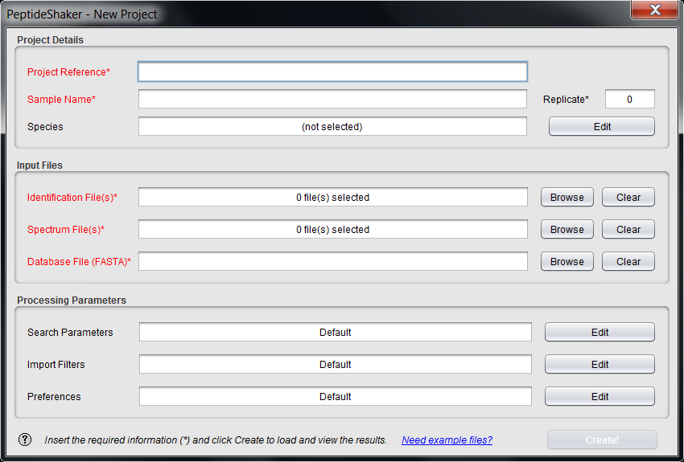

Note the question mark at the bottom left. These are present throughout PeptideShaker and will open contextual help. Additional example files are also available on our website.

Start by giving your project and sample a name at the top, and leave replicate number at 0. We will not take advantage of these details in this exercise, but such annotation is crucial for later (re-)use for real projects!

The species of interest for this sample is human: this is in fact a measurement of a HeLa lysate, courtesy of the Leibniz-Institut für Analytische Wissenschaften - ISAS - e. V., Dortmund, Germany. Click ‘Edit’ in front of Species and select ‘Homo Sapiens [Ensembl 69]’ as displayed below.

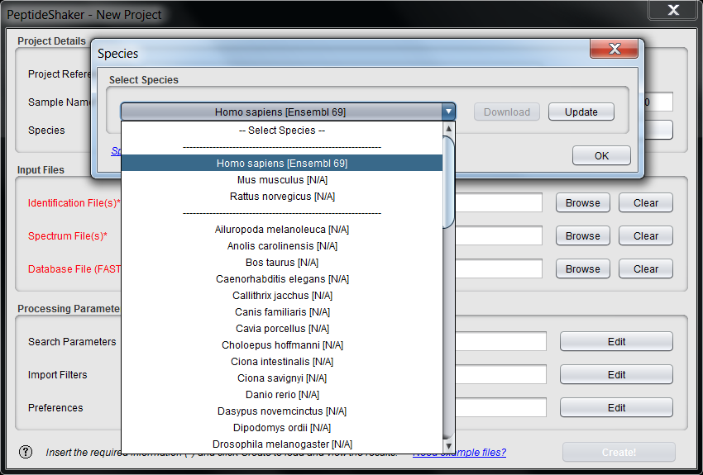

Now we are ready to add the search result files. Click the ‘Browse’ button next to the ‘Identification File(s)’ text field. Navigate to the resources folder, select the OMSSA and X!Tandem result files (qExactive01819.omx and qExactive01819.t.xml) and click ‘Add’.

Notice that the spectrum files and the database are automatically filled in when using results from SearchGUI. Otherwise you have to load these manually (files are in the resources folder). Note also that the descriptions of the processing parameters have changed. This information was extracted from the searchGUI_input.txt file and the parameters file created by SearchGUIalong with the identification files. Note that if files have been moved in the interim, they have to be added manually.

Once all the files have been loaded, click the ‘Edit’ button for the ‘Search Parameters’. You should see this dialog appearing:

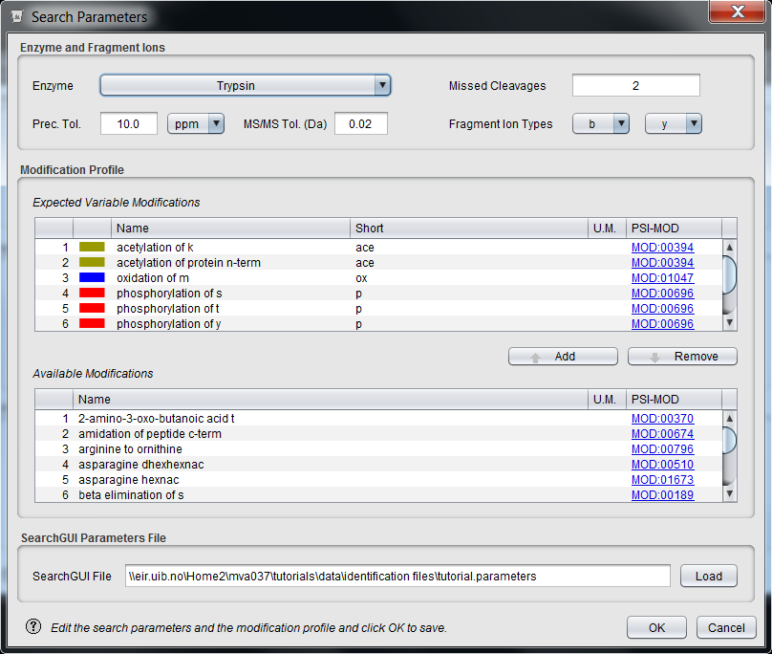

This lists all the parameters used during the search. You should pay careful attention to the modification profile. Only the modifications listed on the table ‘Expected Variable Modifications’ will be recognized by PeptideShaker. It is fine if additional modifications are present, you do not have to remove them.

Note that when loading data from SearchGUI, all of them will be completed automatically. Note that SearchGUI added several modifications we did not search for: acetylation, pyro-cmc and pyro-Glu. *Why do so?*

*After a standard search, X!Tandem performs a so-called second pass search where it automatically looks for extra peptides carrying these modifications. SearchGUI hence passed this information to PeptideShaker. This second pass search has the advantage to bring new identifications, however, note that it biases the way we estimate our error rates.**2* *This will be the subject of the next chapter.*

Click ‘OK’ to go back to the New Project dialog and then click ‘Create!’ to load the data. The selected files will now be loaded into PeptideShaker, and you can follow the progress in the dialog while browsing some PeptideShaker usage tips.

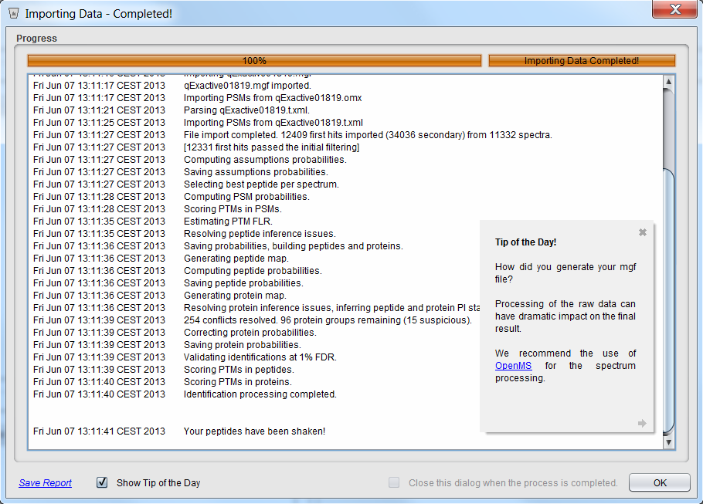

When finished, the dialog closes and the identification results are displayed, you should see something like this:

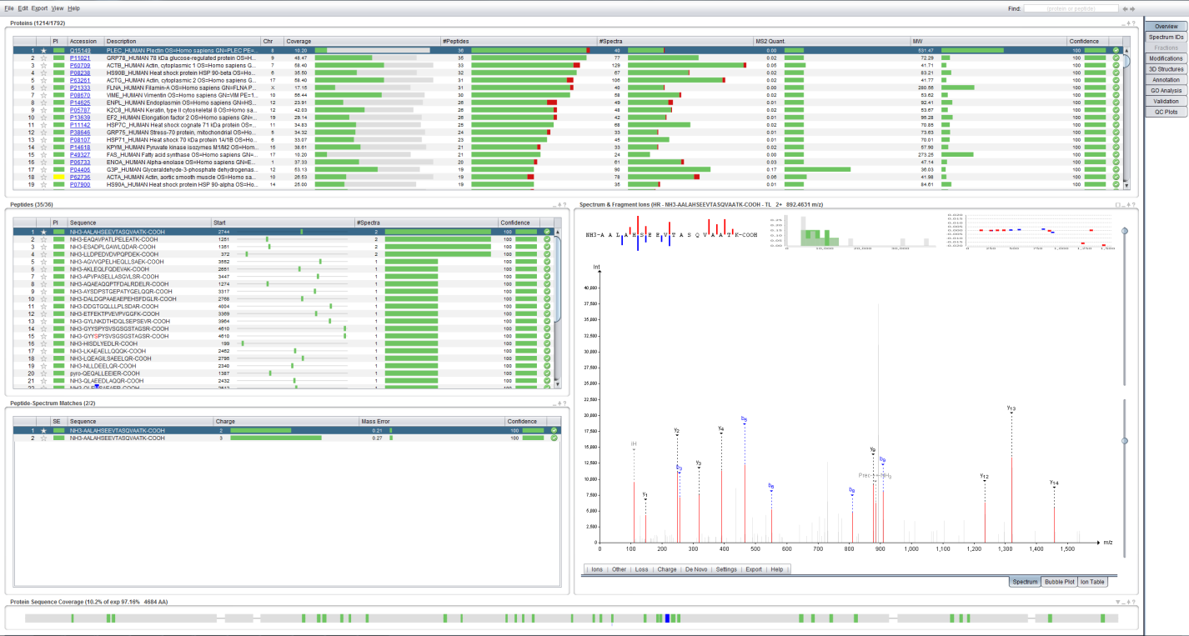

This is the main screen of PeptideShaker and it gives you an overview of the results in your files. PeptideShaker is split into various tabs found in the upper right corner, each with a different function.

The Overview tab is split into five main sections: the protein table at the top; the peptide and peptide to spectrum match (PSM) tables, both in the middle left; the spectrum view in the middle right; and the sequence coverage panel at the bottom. All five sections are connected. This means that selecting a protein in the protein table updates the peptide table, the PSM table, the spectrum view and the sequence coverage panel. Try selecting some of the other proteins in the protein list and see how the other sections are updated accordingly.

At the top right of every section there are small icons allowing you to interact with the data displayed: a square to maximize the section, an underscore to minimize it, an arrow to export the content and a question mark to open contextual help.

Before doing anything else we will start by saving our PeptideShaker project. This way we do not have to reload all the data the next time we want to look at them, but can rather do a much faster load of the project directly. To save your project, go to the ‘File’ menu and click the ‘Save As’ item (or type Ctrl + S), PeptideShaker offers you different options:

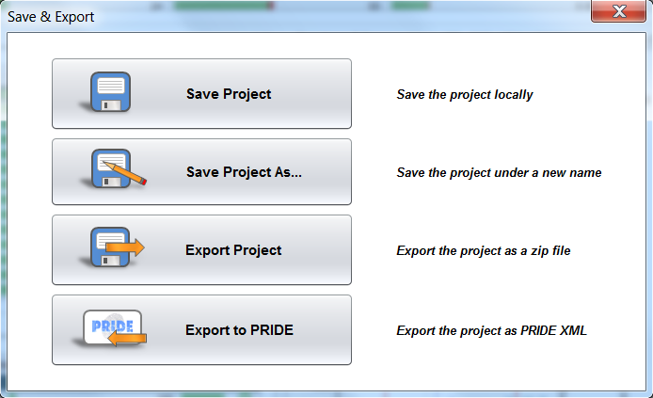

‘Save’ and ‘Save Project As…’ Allow you to save the project in the PeptideShaker format (.cps files). ‘Export Project’ exports the project together with all related spectrum and database files. This option is particularly interesting to share your results: send the zip file to a colleague, after unzipping he will be able to open your project in PeptideShaker in few clicks and interact with your results. ‘Export to PRIDE’ allows you to save your project in the PRIDE format, this will be the subject of the “Public Repositories” chapter. For now, click on ‘Save Project As…’, choose a name for your data file, and click ‘Save’. Note that saving can take time: there is a lot of information to store!

A .cps file should now have been created. If you want to open this project later on you simply have to open this cps file in PeptideShaker. Also note that the project can be accessed via ‘Open Recent Project’ in the start dialog on the 'File' menu.

As already mentioned, protein identification using mass spectral data always starts with the spectra. We will therefore start by looking at a particular spectrum in detail and see how well this corresponds to the identified peptide.

Start by selecting the first protein in the protein table, the one with the protein accession number Q15149, with the descriptionPLEC_HUMAN Plectin and attached to chromosome 8.

Looking at the row for this protein we see that we have covered 10.20 % of the protein's amino acid sequence, detecting a total of 36 peptides from 40 spectra. *Why are there more spectra than peptides*? *How do you define a peptide?*

*Modern mass spectrometers have a high sequencing rate and it is normal to see multiple measurements of the same peptide. When optimizing the mass spectrometer settings, one tries to reduce this effect in order to improve sample coverage.*

*The notion of peptide is however not fixed with regards to charge and modification status. In PeptideShaker, a peptide is considered as able to carry different charges but the same sequence presenting different modification statuses will be considered as two different peptide entities. More details on peptide inference will be given in the “PTM Analysis” chapter.*

In the peptide table, you will see that some amino-acids are colored. These residues were identified as carrying a post-translational modification (PTM). In fact, for an easy interpretation, PTMs are color coded everywhere in PeptideShaker. *How many modified peptides were identifed for this protein?*

*Line 15: GYYSPYSVSGSGSGSTAGSR was found phosphorylated on serine 4. However, the localization of the phosphorylation is not confident: only the letter carries the color – more details on PTM localization will be given in the “PTM Analysis” chapter.*

**Tip:**  
*By default only variable modifications are displayed. You can change this in the ‘View’ Menu.*

*Line 22: QLEMSAEAER was found oxidized on methionine 4.*

*Line 36: ELYQQLQRGER was found phosphorylated on thyrosine 3.*

*Peptides at lines 20, 23, 24, 25, 35 and 36 were carrying a pyro-cmc modification.*

Make sure that the first peptide sequence AALAHSEEVTASQVAATK is selected. In the peptide to spectrum matches table you will see that this peptide is found two times. That means that two different spectra have been identified as the peptide in question. Also notice that one has a precursor charge of 2+, while other has a charge of 3+. *Why do not all precursors carry the same charge?*

*Depending on the elution and ionization conditions, the exact same peptide can end up being recorded at two different charge states. Here, the spectra were recorded at time points separated by only three seconds.*

Now look for the peptide sequence AKLEQLFQDEVAK. The spectrum used to identify the peptide is now shown to the right of the table, and should look like this:

\\eir.uib.no\Home2\mva037\tutorials\1- identification\14- Identification Results\illustrations\AKLEQLFQDEVAK1.tiff

*By looking at the spectrum, is it obvious that this spectrum is identified as the sequence* AKLEQLFQDEVAK*?* *Which are the different ions displayed here? Are the same ions detected in all peptide to spectrum matches or peptides?*

*At the top left of the screen, you can see which parts of the sequence are covered in the spectrum and at which intensity. Such a full coverage is very rare and leaves little doubt on the quality of the identification. In the middle, an histogram shows the distribution of the peak intensities – in green, identified peaks, in grey non identified. One clearly sees here that the most intense peaks are almost all annotated with a fragment ion which is again synonymous of quality for the identification. Finally, on the top right are displayed the fragment ion mass errors at their respective mass. One can see that all ions are very accurately identified, leaving little doubt on the peptide identification. Note that the error is increasing with the mass, as expected from the “Peptide-Spectrum Matching” chapter.*

*As a result, the spectrum is very nicely annotated with two series of b and y ions. These ions are the ones we used for the identification. PeptideShaker also annotates iF which is a commonly observed immonium ion for the amino-acid Phenylalanine.**3* *Some other ions presenting neutral losses are also annotated.*

*The ions detected are heavily dependent on the experimental workflow and the peptide species.*

The menu bar below the spectrum allows you to fine tune the annotation settings and the spectrum display. It is moreover possible to export the spectrum in various formats. Note that only the highest peaks are annotated. You can change the annotation level by scrolling when over the spectrum. If you hold ‘Ctrl’ and scroll, the m/z tolerance will be changed.

**Tip:**  
*You can also change the annotation tolerances using sliders which can be enabled in the ‘View’ menu.*

Before continuing, makes sure that the intensity level is at 75% and the accuracy at 0.5 Da.

The first thing we will do is see how well the spectrum matches the sequence it has supposedly identified. To do this we will perform a bit of manual *de novo* sequencing, essentially checking whether the detected fragment ions match the peptide sequence. We will start with the y-ions, so disable the display of b-ions by clicking the 'Ions' menu below the spectrum and unselecting the ‘b’ ion in the list.

Neutral losses are selected automatically by PeptideShaker depending on the peptide sequence and modification status of the peptide. In order to hide the fragment ions with a neutral loss, unselect ‘Adapt’ in the ‘Loss’ menu, and then deselect the neutral losses one by one.

To make the sequencing a bit easier we will also hide the other sections of the Overview tab. Click on the square on the top right of the spectrum panel. Note that other tabs have been minimized at the bottom left of the screen. The spectrum should now cover the whole screen:

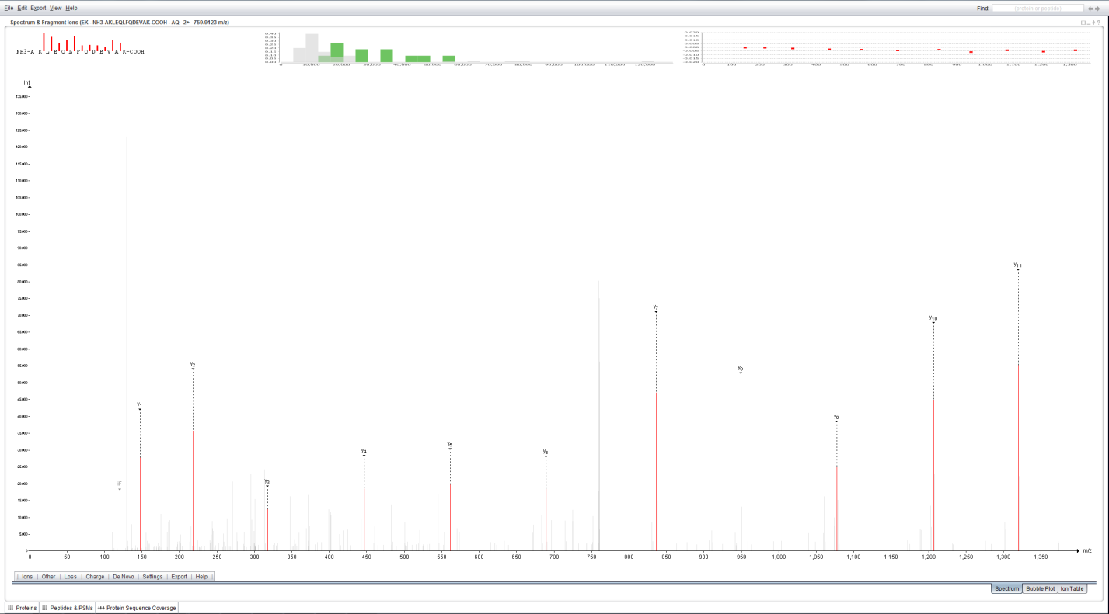

Next, to make the sequencing even easier, zoom in on the m/z range covered by the y-ions y1 to y11, simply by clicking and holding the left mouse button from just before the y1-ion and (while holding the left mouse button pressed) dragging the mouse horizontally to the right until you have passed the y11-ion. At that point just let go of the left mouse button to zoom in on the selected range. If you want to zoom in further, you can repeat the same procedure. If you at any point want to zoom out again, simply click the right mouse button to return to the full spectrum display.

Now start the *de novo* sequencing by first clicking the y1-ion. If you still find it difficult to click the correct peak, try zooming in just on the peak in question, select it, and then zoom back out again.

**Tip:**  
*in order to click a peak, it first needs to be highlighted (showing its exact m/z and intensity above the peak) and this highlighting only occurs if the mouse is held above the peak within 1.5 times the peak height.*

Continue the sequencing by clicking the y-ions in ascending order from left to right. If you click the wrong peak, the last selection can be removed by holding down the Shift key while clicking the peak again. Ctrl + click will save the current sequence, and will allow you to start a second sequence.

When done, you should have a spectrum display that looks something like this:

\\eir.uib.no\Home2\mva037\tutorials\1- identification\14- Identification Results\illustrations\AKLEQLFQDEVAK2.tiff

If you now read the sequence at the top you will find that it reads (from left to right): A, V, E D, Q GA, F, I/L, Q GA, E, I/L. Given that y-ions are indexed from right to left (carboxy-terminus to amino-terminus) relative to the sequence, we have to reverse the sequence to match it to the peptide sequence. Hence we get the sequence: I/L E Q/GA I/L F Q/GA E V A. Comparing this to the peptide sequence we see that they are very similar, and if we resolve the ambiguous residues, we have a perfect match to the proposed peptide's sequence from residue 3 - 12. *Why do we not have complete coverage? And why is complete coverage in most cases not necessary? Where do the ambiguous residues come from? Can they impact the final result? What is the role of modifications in the ambiguity? Can you relate this to identification issues when many (variable) modifications need to be considered?*

*Peptides fragment at different places with different yields. As a result, some fragment ions are usually missing. The experimentalist optimizes the fragmentation conditions in order to get the best sequence coverage – but a full coverage is often impossible. In most cases however, a partial coverage is sufficient for confident peptide identification as only one candidate from the database would match the measured sets of fragment ions.*

*The ambiguous residues are amino-acids and sets of amino-acids presenting the same mass. The most famous case is the Isoleucine Leucine couple. These can create systematic errors, hence biasing the error rate estimation**4* *and protein inference. The number of ambiguous cases obviously grows when taking into account more variable modifications.*

In the ‘De Novo’ menu, select ‘y-ions’, PeptideShaker then shows you the solution retained for this spectrum.

\\eir.uib.no\Home2\mva037\tutorials\1- identification\14- Identification Results\illustrations\AKLEQLFQDEVAK3.tiff

Now, enable the display of b-ions and select ‘b-ions’ in ‘De Novo’. You should see the following screen:

\\eir.uib.no\Home2\mva037\tutorials\1- identification\14- Identification Results\illustrations\AKLEQLFQDEVAK4.tiff

Note that in this case you can only use b2 to b7 and b9 to b11. Remember that b-ions are indexed from the left to the right (amino-terminus to carboxy-terminus), so in this case you don't have to reverse the sequence. *Why do we have lower coverage and intensity for b-ions relative to the y-ions for the same peptide? Is this the same for all peptides, all instruments, all protocols?*

*For a trypsin digest, the C-terminus is more likely to carry a charge and hence more likely to be measured. As a result, y ions are typically more intense than b ions. The relative intensity levels are however heavily peptide, sample and experiment dependent.*

When you are done sequencing, make sure that both the b- and the y-ion types are selected in the menu below the spectrum, and click the ‘Ion Table’ tab in the lower right corner.

Here you will see an overview of the detected fragment ions and how they correspond to the sequence of the peptide. *How do the results here correspond to the results you found in your de novo sequencing?*

*The table displays exactly the same intensities as the ones used for de novo.*

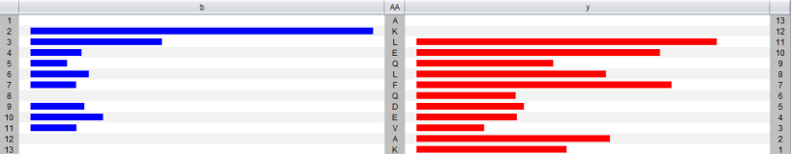

In the Settings menu below the table you can select m/z based display instead of intensity:

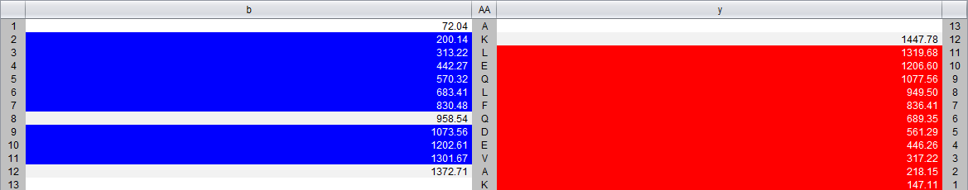

We will now move one step further by comparing multiple spectra identified as the same peptide. Bring the spectrum panel back to its normal size by clicking on the square and select the second protein in the list: P11021. You will see that the first peptide has been identified in 6 spectra: 4 with a charge of 2+, 2 with a charge of 3+. While holding down the Ctrl-key, select all spectra with a charge of 2+. You should see this:

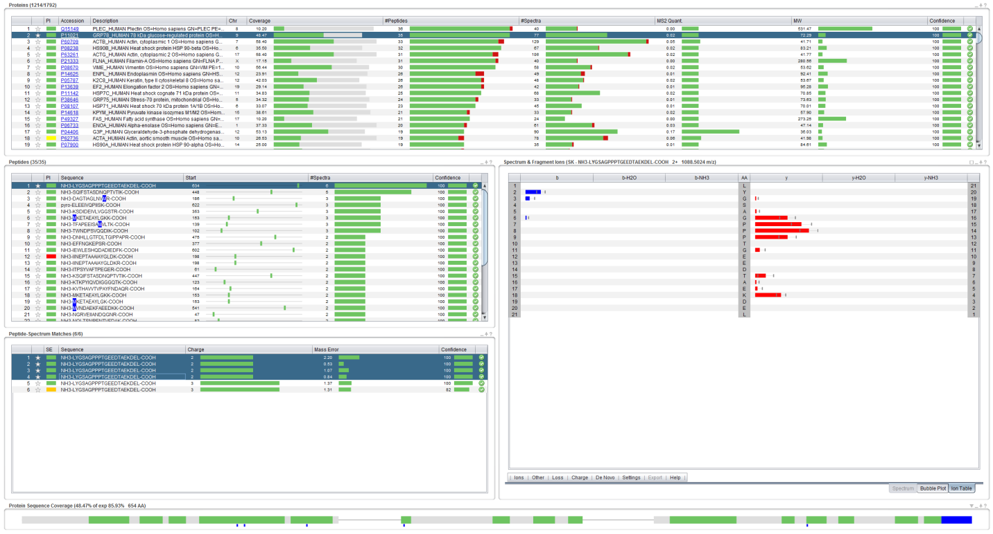

The intensity difference between the spectra is displayed with error bars. *Do you expect reproducibility in intensities between spectra? What do you think about the comparison between 2+ and 3+ PSMs?*

*With modern instruments, fragment ion intensities are extremely reproducible. These however strongly depend on the charge state of the precursor and modification status of the peptide.*

In a standard visual inspection of both spectra (select them one by one in the PSM table and look at each spectrum) it can be difficult to tell how similar they are. Attempting to see which fragment ions are detected in all of the spectra, and at which intensities, is also very hard.

For this purpose a novel view has been developed, referred to as the bubble view or the *Planetary System View*. You will find this view by clicking the ‘Bubble Plot’ tab below the spectrum (or by simply selecting more than one row in the spectrum table). Selecting/highlighting all the rows in the PSM table with the same charge should give you something like the figure below.

In this view of the spectra we still have the m/z value on the x-axis, but on the y-axis we now have the mass error (the distance between the theoretical and the experimental mass of the fragment ions). The size of each bubble represents the (normalized) intensity of each fragment ion.

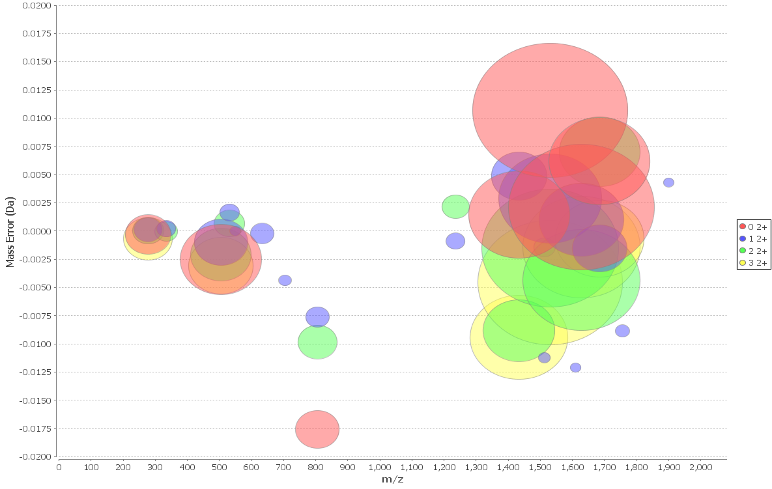

This way of looking at multiple spectra takes a bit of getting used to, but once one is comfortable with the setup, it becomes very easy to pick up details that would have been very difficult to see by a manual inspection of each spectrum individually. *Now, what do you think about the error distributions?*

*The error clearly goes down for high masses as the PSM number increases. In fact, PSMs are sorted by increasing retention time: 1652 s, 1666 s, 1679 s and 1693. One observes here the fluctuation of the instrument calibration at high masses over time. This can be due to minor temperature fluctuations for instance. Note that the mass deviation stays between ±0.01 Da, safely below the ±0.02 boundaries set for the search.*

We will now study the sequence coverage of the selected protein – P11021. The sequence coverage is indicated in the protein table, 48.47% and illustrated at the bottom in the Protein Sequence Coverage panel:

\\eir.uib.no\Home2\mva037\tutorials\1- identification\14- Identification Results\illustrations\coverage1.png

The 35 identified peptides are mapped onto the sequence in green whereas the non-covered parts are left in grey. Note that the parts of the sequence which do not generate observable peptides are thinner than the others. For this protein, the observable coverage was estimated to 85.93%, actually, some might have observed that the observable coverage is readily displayed in the protein table.

If you hold the mouse over a part of the sequence, the observed peptides will be displayed. *The currently selected peptide is displayed in blue, what is the first peptide observed on the sequence?*

*It is peptide NGRVEIIANDQGNR at position 47.*

Note that this peptide contains a missed cleavage and that the cleaved version is also detected. Also, keen observers will have noticed that the modifications are readily mapped under the sequence. Clicking over the corresponding part allows the selection of the oxidized peptide:

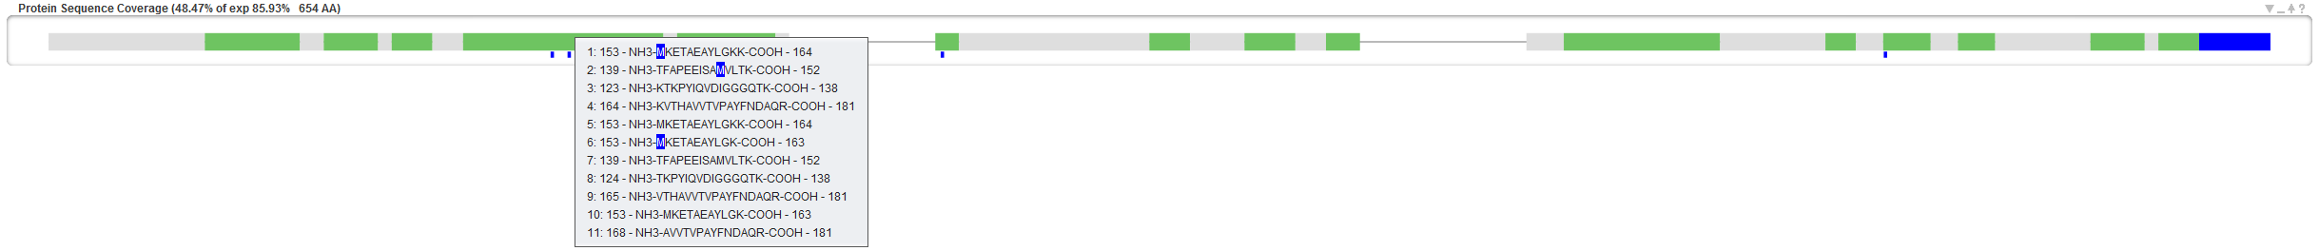

*How many modified peptides does this protein contain? How many modification sites?*

*6 peptides were found oxidized (lines 3, 6, 7, 19, 20 and 34 in the peptide table) resulting in 5 oxidation sites on the protein sequence (M148, M153, M196, M263 and M541).*

More details on PTM localization will be given in the “PTM Analysis” chapter.

1. Quality Control

Before further investigation, it is important to verify the quality of the search. We will start by verifying that all search engines worked correctly. As you remember, we loaded identification results from OMSSA and X!Tandem. Note that it is also possible to load Mascot results (<https://code.google.com/p/peptide-shaker/#Mascot_Support>). Open the tab called ‘Spectrum IDs’ in the upper right corner, loading a tab can take a few seconds. When PeptideShaker is busy with a process its icon turns orange. When finished it turns grey again to inform you that the coffee break is over!

At the top you should now see something like this:



This view shows you how well the search engine results overlap at the PSM level. If the bubble representing a search engine is substantially smaller, bigger or decentred compared to the other(s), it is worth verifying that the search did not encounter any unexpected issues and that the same search settings and database were used for all search engines. As you can see here they are pretty close but not identical. *Why are the search engine results different? Will the differences depend on the dataset used? Can we take advantage of these differences?*

*Search engines have complementary features, notably in terms of spectrum filtering and in-sillico fragmentations. Also, X!Tandem has an implemented second pass search bringing additional PSMs as illustrated on the Venn diagram. PeptideShaker takes advantage of these complementarities to increase the identification rate. Moreover, depending on the sample complexity, labelling or fragmentation methods, a search engine can underperform. Having different algorithms is a gage of stability. In such cases, the problem is easily spotted by the Venn diagram and a new project can be created excluding the underperforming search engine.*

The rest of the ‘Spectrum IDs’ tab allows you to browse the search engine results and see how PeptideShaker combines the separate search engine results into a single result set. By clicking a spectrum in the spectrum table on the left you will see the PSM for the two search engines and how these were scored. The selected PSM will be used to annotate the given spectrum.

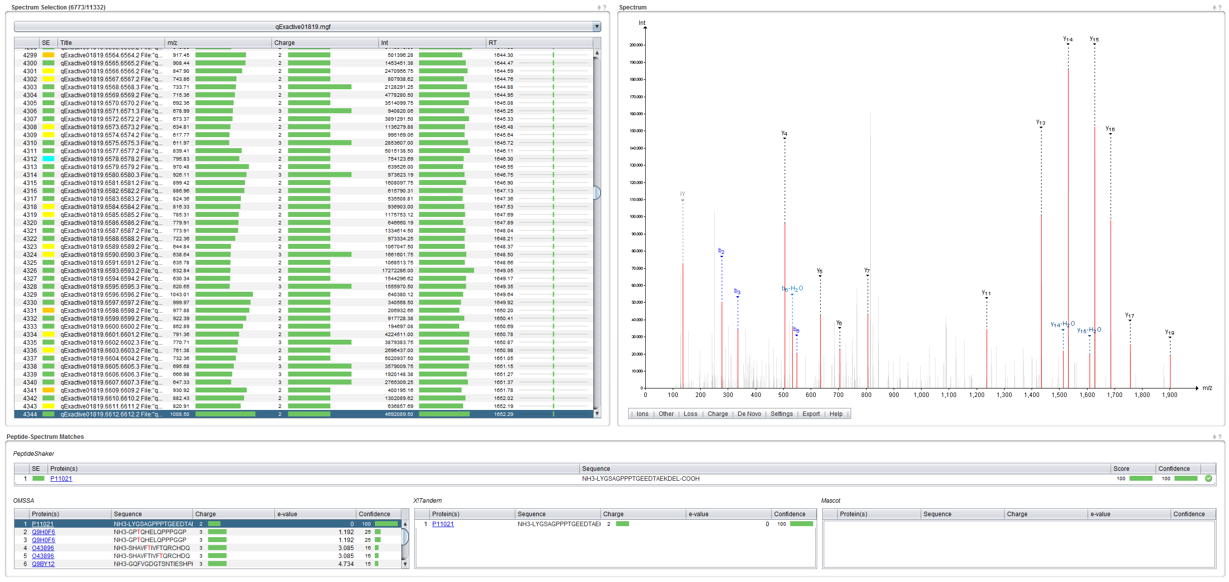

**Tip:**  
*If you are interested in non-assigned spectra, you can export them using the ‘Follow Up Analysis’ option in the ‘Export’ menu.*

Note the SE (Search Engine) column which indicates whether a spectrum was identified and if so, whether the search engines agreed on the identification. Click on the row 4343, spectrum qExactive01819.6611.6611.2 File:"qExactive01819.raw", NativeID:"controllerType=0 controllerNumber=1 scan=6611", with a yellow square. You should see this:

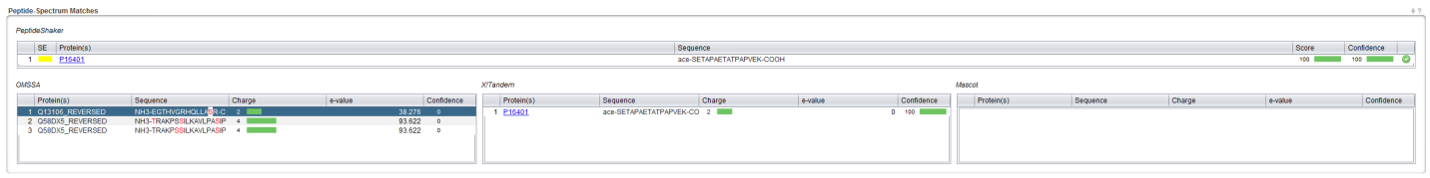

As you can see, a peptide found by X!Tandem took precedence over another suggested by OMSSA. *Which of the possibilities is the best match in your opinion?* *Would you trust peptides where the search engines disagree?*

*Here the hit proposed by X!Tandem is clearly better than the one found by OMSSA, as seen from the respective confidences and spectrum annotation. In fact, X!Tandem found this acetylated peptide during the second pass search – while OMSSA was not searching for acetylated peptides. OMSSA and X!Tandem are hence not looking at the spectrum with the same glasses, explaining the dramatic difference between the results.*

*On the other hand, when the search engines come up with different solutions with comparable confidence, the match can reasonably be considered as doubtful. This is notably the case when search engines infer conflicting PTM localizations – an effect which is translated in a score in PeptideShaker, the D-score.**5*

Now, select the ‘QC Plots’ tab. In this tab, some Quality Control metrics are given for the proteins, peptides and PSMs. The category (Proteins, Peptides, PSMs) is selected at the bottom right corner of the screen.

The default view is the Protein option, and you should now see the distribution of proteins according to their amount of identified peptides:

\\eir.uib.no\Home2\mva037\tutorials\1- identification\14- Identification Results\illustrations\QC1.tiff

*How many peptides would you require to trust a protein identification?*

*Generally in proteomics, in order to avoid so-called one hit wonders, one requires two different peptides per protein. This is illustrated by the fact that our estimated number of validated false protein identification matches is solely found in the one peptide category. More details on the false and true positives will be given in the “Peptide and Protein Validation” chapter.*

*However, this does not imply that all single peptide hit proteins shall be discarded. They should be considered with care.*

For the sake of brevity, we will not go through all quality control plots but feel free to explore them by yourself. We welcome any questions/suggestions!

1. Protein Inference

When building proteins from peptides, it can be impossible to decide between two proteins that share the same peptide(s). This issue is known as the protein inference problem.6 Go back to the ‘Overview' tab and sort the proteins by the PI column by clicking the column header twice. PI stands for Protein Inference, and the proteins are now sorted so that the proteins with protein inference issues are at the top.

In PeptideShaker, proteins are flagged using four colors: green, yellow, blue and red; as you see, here we do not have an example of a blue category protein. For the best overview, hide all sections but the Protein table:

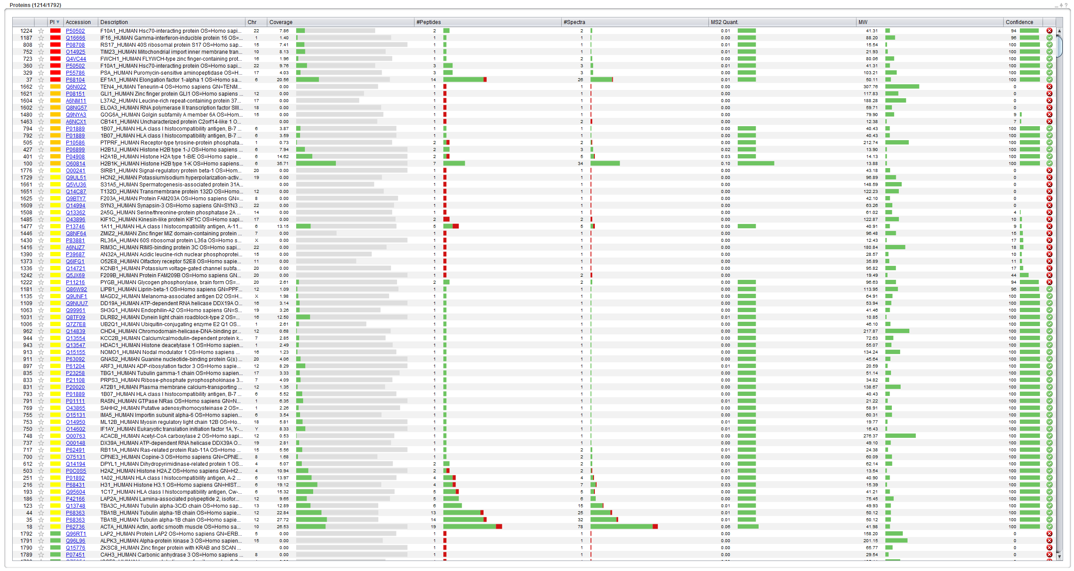

Click on the red box corresponding to protein accession number P68104, and a Protein Inference Dialog appears, displaying two proteins. PeptideShaker could not decide whether P68104 or Q5VTE0 was present in the sample as the identified peptides are all shared by the two proteins. *According to the description, are these two proteins very different?*

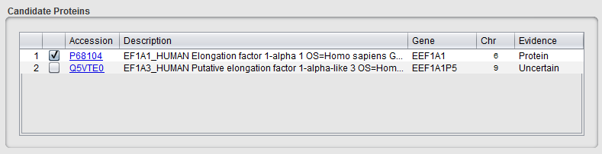

*From the description, one can expect these proteins to be very similar, hence having high sequence similarity and being very difficult to distinguish by peptide centric mass spectrometry based proteomics.*

Note that these two proteins are attached to different genes and chromosomes. Choosing one or the other can hence strongly impact the biological interpretation of the results! Also, keen observers will have noticed that PeptideShaker chose the version with the highest evidence according to Unitprot.7

**Tip:**  
*In order to benefit from comprehensive protein annotation, we recommend the use of Uniprot databases.*

Inferring proteins from peptides is not as simple as it may seem. Some peptides can map to different proteins, let’s say protein A and protein B. If no unique peptide unambiguously indicates the presence of either protein A or B, PeptideShaker cannot say whether protein A or protein B is present.

Confidence

A

B

AB

B

AB

A

A

B

AB

Case 3

Threshold

Case 1

Case 2

*In this simple example, how do you interpret the various cases?*

*Here is how*

*Case 1: A and B are identified, the group AB is deleted.*

*Case2: A is identified and A or B is identified, the group AB remains*

*Case 3: A or B is identified, the group AB remains.*

*In all cases, the peptides of the group AB are also attached to A and B, hence visible in the table flagged with a different PI status than the unique peptides. The shared peptides are however not used for scoring purposes.*

Often, the problem is a lot more complex and involves dozens of intricate peptide to protein mappings. PeptideShaker solves protein inferences of Case 1 and 2, as you may have noticed when loading the identification files. However, Case 3 requires additional information about the sample to find out, if possible, which protein was actually present. These types of conflicts are in the PI column colored in yellow, orange and red depending on the properties of the conflict. By clicking on the corresponding box (as we have done above), you can manually select the protein you consider as the correct one.

In most cases, the protein groups are isoforms of the same protein. Based on the protein descriptions, PeptideShaker sorts the protein inference conflicts into four categories:

* Green: No Conflict, i.e., a Single Protein unambiguously identified
* Yellow: Isoforms identified
* Orange: Unrelated Isoforms identified
* Red: Unrelated Proteins identified

*Based on the P68104 example, how accurate is the sorting?*

*This sorting is a very imprecise sorting. It tends to be very conservative and flag more problematic cases as there actually are.*

The conflict type can be edited in the Protein Inference Dialog.

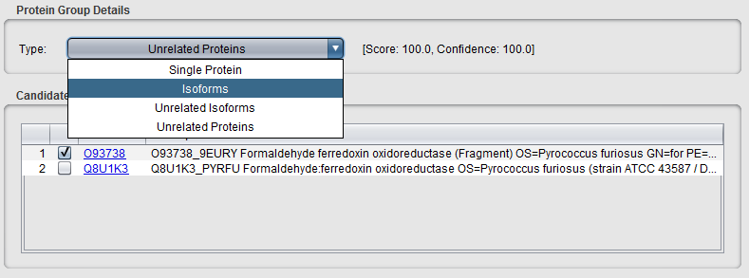

Let’s say that we are not much worried by the differences between P68104 or Q5VTE0, we can hence mark this group as Isoforms. The group is now yellow flagged in the PI column of the protein table.

Now look for protein P55786 (row index 329), and click on the red box in the PI column. A dialog similar to the following should appear:

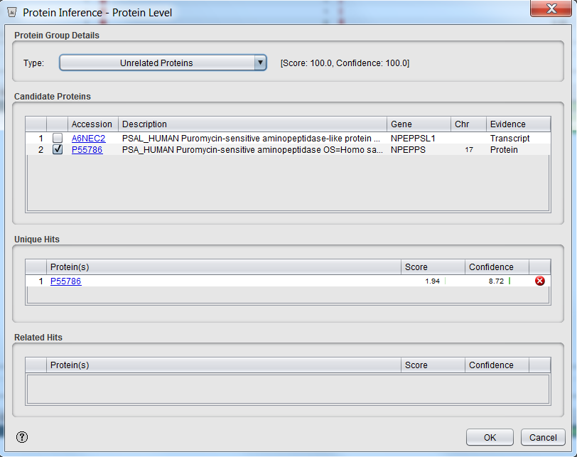

Here, peptides belonging to A6NEC2 were found shared with P55786 with a high confidence (100%), P55786 was chosen as main hit because of its evidence status. Here, PeptideShaker direcly shows you that P55786 was also identified by unique peptides but at a much moderate confidence (8.72%). As a result, A6NEC2 will appear twice in the protein table: once as a group (P55786 or A6NEC2) and once as unique hit (P55786).

In order to navigate these hits, we will use the Find feature of PeptideShaker: type P55786on the top right corner of the interface.

\\eir.uib.no\Home2\mva037\tutorials\1- identification\14- Identification Results\illustrations\jump to.png

Using the two arrows, you can navigate the two groups related to this accession. *Select the unique protein hit, can you find the unique peptide?*

**Tip:**  
*The Find function accepts protein accessions, descriptions and even peptide sequences!*

*The unique peptide, LSVEGFAV, is flagged in green in the PI column of the Peptides table. Note that it presents a very low score and almost no annotated peaks in the spectrum supporting its identification. This group is thus clearly not reliable.*

Note that you can change the retained accession for any group.

*Can we delete a useless group?*

*It is necessary to keep all groups for scoring reasons. This will be further detailed in the “Peptide and Protein Validation” chapter.*

Similarly, if peptides shared with one of these proteins were found in another group, the group is reported in the 'Related Hits': for the group (P50502 or Q8IZP2) at line 360, P50502 is shared with the group (P50502 or Q8NFI4) line 1224 which was identified at a lower confidence level (94.20%) and was hence not retained:

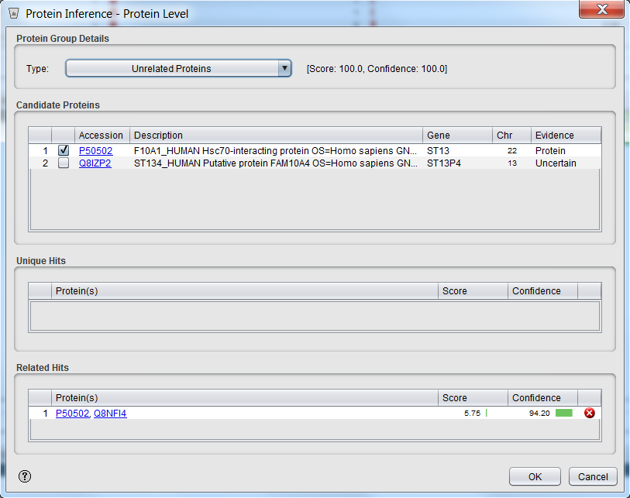

*Can we avoid protein inference issues in shotgun proteomics?*

*The protein inference problem is inherent to peptide-centric proteomics and can hence not be avoided. However, two factors dramatically reduce the prominence of that problem: (A) the improved identification of unique peptides which follows technical improvements and (B) the curation of databases: most of the secondary matches displayed in this tutorial are very unlikely to be identified when compared to the main match. Using a clean database hence dramatically simplifies the interpretation of the results.*

*When protein inference issues are actually impairing the scientific outcome of an experiment, it is possible to enrich for unique peptides like terminal peptides**8* *or to decipher the problem using targeted proteomics.**9*

References

1. Martens, L. et al. PRIDE: the proteomics identifications database. *Proteomics* **5**, 3537-3545 (2005).

2. Everett, L.J., Bierl, C. & Master, S.R. Unbiased statistical analysis for multi-stage proteomic search strategies. *Journal of proteome research* **9**, 700-707 (2010).

3. Papayannopoulos, I.A. The interpretation of collision-induced dissociation tandem mass spectra of peptides. *Mass Spectrometry Reviews* **14**, 49-73 (1995).

4. Colaert, N., Degroeve, S., Helsens, K. & Martens, L. Analysis of the resolution limitations of peptide identification algorithms. *Journal of proteome research* **10**, 5555-5561 (2011).

5. Vaudel, M. et al. D-score: a search engine independent MD-score. *Proteomics* **13**, 1036-1041 (2013).

6. Nesvizhskii, A.I. & Aebersold, R. Interpretation of shotgun proteomic data: the protein inference problem. *Mol Cell Proteomics* **4**, 1419-1440 (2005).

7. Magrane, M. & Consortium, U. UniProt Knowledgebase: a hub of integrated protein data. *Database : the journal of biological databases and curation* **2011**, bar009 (2011).

8. Gevaert, K. et al. Exploring proteomes and analyzing protein processing by mass spectrometric identification of sorted N-terminal peptides. *Nature biotechnology* **21**, 566-569 (2003).

9. Picotti, P. & Aebersold, R. Selected reaction monitoring-based proteomics: workflows, potential, pitfalls and future directions. *Nature methods* **9**, 555-566 (2012).